REGISTRATION FORM
Stokane National School
Enniscrone
Co Sligo
F26C970
Roll No 14051T Phone 09636673/086 0695093
stokanens@gmail.com
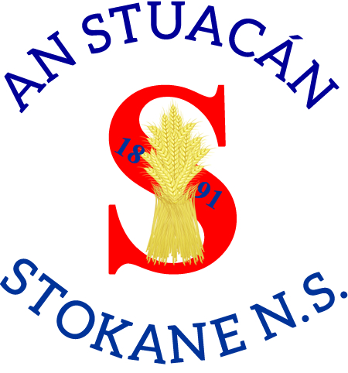

Please complete in BLOCK CAPITALS
Pupil's Name: |  | Name in Irish:  (Optional)
Date of Birth: |  | Male/Female
P.P.S. Number: |  | Country of Birth:
Address: |  | Nationality:
Eircode: |  | If born outside the country, year of arrival in Ireland:
Languages spoken in the home:
Parent/Guardian Details |  | Parent/Guardian Details
First Name: |  | First Name:
Last Name: |  | Last Name:
Relationship to child: |  | Relationship to child:
Phone No (Home): |  | Phone No (Home):
Phone No (Work): |  | Phone No (Work):
Phone No (Mobile): |  | Phone No (Mobile):
email Address: |  | email Address:
Names and dates of birth of other children in the family who may seek entry to the school in the future:

Childs Name:
Are there any orders or other arrangements in place governing access to or custody of your child? Please tick |  |  | Y | N
Details:

Name of Previous School/Pre-school:
Address:
Principal's Name: Phone No:
Additional local contact names, to be contacted in emergencies [Not the same as above]
Name: |  | Phone No:
Relationship to child:
Name: |  | Phone No:
Relationship to child:
Name: |  | Phone No:
Relationship to child:
Please tick |  |  | Yes | No
Have you attached a Birth Certificate for your child?

Childs Name:

Relevant Medical Information
Family Doctor: | Phone No:
Please Tick | Yes | No
Any medical concern/information of relevance?

Details

Medical conditions we should know about: - Please tick
1. Speech [ ] Hearing [ ] Sight [ ] or other difficulties [ ]
2. Medical Conditions: Asthma [ ] Epilepsy [ ] Heart Conditions [ ] Diabetes [ ] Other [ ]
3. Allergies: Wasp stings [ ] Food [ ] details _______________________________________________
Other allergies: [ ] _____________________________________________________________________
4. Emotional difficulties [ ] details _________________________________________________________
_____________________________________________________________________________________
5. Laterality – Right-handed [ ] Left-handed [ ] Mixed [ ]
6. Please give details and specify any conditions not listed above which might be considered to affect the child’s ability to benefit from school. If there are any (medical) reports in relation to any of the above, please share a copy of same.

7. Does your child require regular medication? Yes [ ] No [ ] If yes please give details

REGISTRATION FORM
Stokane National School
Enniscrone
Co Sligo
F26C970
Roll No 14051T Phone 09636673/086 0695093
stokanens@gmail.com
Consent Form

We would like your permission for the following in relation to your child
Childs Name :

Please Tick | Yes | No
School Policies
I/We have read a copy of Stokane NS Code of Behaviour and agree that my child and I will abide by it.
I/We agree to familiarise myself with ALL school policies, agree to abide by them and agree to discuss them at an appropriate level with my child.
All available on the school website * www.stokanens.ie
Technology
I/We give consent for my child to use the computers/iPads in the school in line with our Acceptable Use Policy.
School Website/Publications: I/We give consent for the use of school related photographic images which include my child on the school website, school Facebook, X or in other school publications or displays. I understand that they will not be identified individually.
Dept of Education & Skills
I/We give written parental consent to share Ethnic or Cultural Background and Religion with the Department of Education & Skills.
Medical Emergencies
I/We give permission for my child to receive any medical attention deemed necessary and to be taken to hospital in case of serious illness or accident.
Special Education Teaching (SET)
I/We give permission for my child to receive SET Support if required
Child Abuse Prevention programme
I/We understand and accept my child’s participation in the Stay Safe and RSE (Relationships and Sexuality Education) Programmes.
Educational / Diagnostic Tests
I/We give permission for any educational screening/diagnostic tests to be carried out with my child/children where necessary.
Local Walks
I/We give permission for my child to participate in local walks in the school area.
Parents’ Association
I/We give permission for contact details to be shared with Stokane NS Parents Association.
Competitions
I/We give consent to allow my child to enter school competitions and for their name and date of birth to be shared with the organisers.

*School Policies are available on our website and hard copies can be supplied on request.

Stokane National School is registered as a Data Controller under the Data Protections Acts 1988 and 2003 and we follow GDPR regulations as set down in 2018. The personal data supplied on this application form is required for the purpose of student enrolment, registration, administration, child welfare and to fulfil our legal obligations. Contact details will be used to notify you of school events/activities. While the information provided will be treated as confidential to Stokane N.S it may be necessary for us to exchange information on a confidential basis, where we are legally required to do so, with other bodies including the Department of Education and Skills, the Department of Social Protection and Family Affairs, an Garda Siochána, the Health Service Executive, Túsla and other schools where a pupil is transferring. We rely on parents/guardians to provide us with accurate and complete information and to update us in relation to and changes in the information provided. Should a parent wish to update their own or their child’s personal data, they should put the amendment/s in writing to the school principal.
Childs Name:

Signed:

Parent/Guardian Date:
Signed:

Parent/Guardian Date:
I/We wish to enrol my/our child in Stokane National School
Childs Name:

Signed:

Parent/Guardian Date:
Signed:

Parent/Guardian Date:
Both Parents/Guardians to sign

